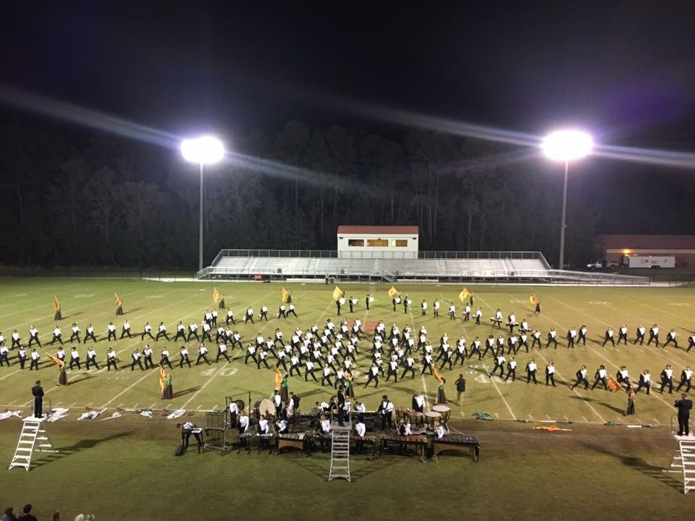  MARCH 2017  RHHS Band Booster Minutes  *New Band Web Page is now up and running at richmondhillhighschoolband.org  Directors Report  - Danny Kiene cell phone # 912-414-2830. Please remember that this is a private cell phone. Texting does work best. Pease identify yourself, child’s name, and topic of conversation. Think about the level of emergency if you are calling after hours or on the weekends.  - Jakob Richardson will be doing the shelves in the band room for all of the trophies as his Eagle Scout project this year. Any donations, volunteers, etc…. would be appreciated.  SPRING TRIP INFO……  - Dates- April 21, 22, 23---We will leave very early on the morning of the 21st and return around 8pm on the 23rd. This will allow for 2 FULL days at Universal Studios and Sunday 1 day at Sea World Aquatica before heading home. The band will march in a parade through Universal on Saturday afternoon.  - 4/3/17 the final balance towards the trip is due. This is where fundraising money will be taken into account and deducted from remaining balance. Please remember that all money up to this point needs to be collected so that we may pay the tour company as we are required to do.  - If you pay for the trip in FULL and your student can not go, there will not be a refund. However, your student would receive the tickets purchased (for example: 2 Universal tickets) once the band  - Students will be staying at the Embassy Suites Lake Beuna Vista located at 4955 Kyngs Heath Road Kissimmee FL 34746  (407-597-4112) | *4/6/17 Band Booster Meeting  *4/8/17 Car wash/Rummage sale  *4/21/17 – 4/23/17  Universal Studios Band Trip  *4/24/17 Leadership Camp  *4/24/17 -5/5/17  Guard tryouts (off for 8th grade dance)  *5/1/17 Drum Major Camp  *5/6/17 Band Banquet  *5/9/17 Spring Concert  *5/11/17 and 5/12/17  Uniform Fitting/Registration Night  *5/20/17 Graduation  *7/17/17 to 7/28/17 Band Camp  Universal Studios Trip Hotel Info:  Embassy Suites Lake Beuna Vista  4955 Kyngs Heath Road  Kissimmee Fl 34746  407-597-4112
Old Business:
- 2nd Annual Rummage Sale preparation is underway and we are asking for any donations you may have towards this wonderful fundraiser. Storage unit has been obtained & we want it overflowing with your miscellaneous items.
- Car wash dates have been set for 2/25 & 4/8/17 at the Richmond Hill Annex
- Fundraising has been underway and Coke orders should be in soon
- A committee is forming to discuss transportation issues/concerns for next year with the growth potential pushing us over 200 members.
- January 28, 2017 9 – 3pm will be an inventory of all uniforms day. Volunteers are needed.
New Business:
Treasurer Report:
- The 2017 – 2018 budget is still being worked on and will be presented at the April 2017 booster meeting.
- Payments are still being collected for annual band fees
- Final invoices have been sent out and ALL Universal trip payments are now due
Uniform Report:
- Uniform inventory day went well and many pieces were found to be salvageable
- At this time we are still in discussions on how many new uniforms will be ordered to prepare for the influx of rising 8th graders.
- Uniform fitting day this year will be May 11th & 12th in the RHHS band room to better prepare for sizing issues for 2017. More information to come on this
Secretary Report:
- The #1 way to get information regarding what is coming up is to find the directors TWIB (this week in band) messages on Richmond Hill Wildcat Marching Band Facebook Page. This information comes directly from the band director regarding upcoming events
- Information is put out using facebook pages, Remind text messages, emails when needed, and sent home with students.
- Our new band webpage is now up and running. This will become a vital way for you to get any/all information, documents, calendar updates, etc…. Please check it out at your convenience richmondhillhighschoolband.org
Fundraising Report:
- Car Wash & Rummage Sale went extremely well with students earning a nice amount towards individual accounts.
- Coke sales have concluded and earned amounts have been credited to your students accounts towards the Universal trip
- 4/8/17 #2 Car wash & rummage sale will be held at the high school parking lot 7 am – 5 pm. Volunteers are needed for this to be successful.

Lynn Brown
RHHS Band Booster Secretary

